
FACULTY OF ENGINEERING, SCIENCES AND TECHNOLOGY

DATABASE MANAGEMENT SYSTEMS LAB

PROJECT PROPOSAL

INSTRUCTOR: SHOAIB AHMED

GROUP MEMBERS:
- BURHAN ALI (67491)
- EMAN LIAQUAT (67404)
- SADAF (67400)

INDEX

S.NO | CONTENT | PAGE NO.
1 | Introduction | 3
2 | Objectives | 3-4
3 | Scope | 4-5
4 | System Overview | 5-6
5 | Tools | 6
6 | Methodology | 6-7
7 | Database Design | 7
8 | ER Diagram | 8
9 | Expected Outcomes | 8-9
10 | Conclusion | 9
11 | References | 9

PROJECT TITLE:

ONLINE FOOD ORDER SYSTEM
(DATABASE MANAGEMENT SYSTEM)

INTRODUCTION:
Traditional food ordering systems are often time consuming, manual, and prone to errors such as incorrect orders, delays, and miscommunication between customers and service providers. In today’s fast paced digital world, there is a growing need for an efficient and automated solution that can simplify the ordering process and improve overall service quality.

To overcome these challenges, an Online Food Order System is introduced, which is a database driven application that allows users to browse food items, place orders, and manage transactions in a structured and reliable manner. This system demonstrates the practical implementation of a Database Management System (DBMS) in real world scenarios, particularly in the food delivery industry.

The proposed system ensures fast data retrieval, improved accuracy, and better organization of information, making the ordering process more convenient for both customers and administrators. It also highlights the importance of data integrity and efficient data handling in modern applications.

OBJECTIVES:
The key objectives of this project are as follows:
- To design and develop a structured database system for an Online Food Order System.
- To efficiently manage and organize customer, menu, order, and transaction data.
- To establish proper relationships between entities using primary and foreign keys.
- To perform CRUD (Create, Read, Update, Delete) operations for effective data handling.
- To write and execute SQL queries for accurate data retrieval, filtering, and reporting.
- To ensure data consistency and integrity using appropriate database constraints.
- To optimize query performance through proper database design and normalization techniques.
- To understand and apply real-world Database Management System (DBMS) concepts in a practical scenario.

SCOPE:
The scope of this project includes the following Database Management System (DBMS) components:

1. Database Design:
- Designing a structured relational database for an Online Food Order System.
- Identifying and defining entities, attributes, and relationships.
- Developing an Entity Relationship (ER) Diagram to represent system structure.

2. Database Structure:
- Creation of tables and defining relationships between them.
- Proper use of Primary Key and Foreign Key constraints.
- Ensuring data integrity through relational design.

3. Database Operations:
- Performing CRUD operations (Insert, Update, Delete, Retrieve).
- Executing SQL queries for efficient data handling and retrieval.
- Generating basic reports using query results.

4. Database Concepts:
- Implementation of normalization techniques (1NF, 2NF, 3NF).
- Application of integrity constraints such as NOT NULL, UNIQUE, and CHECK.
- Ensuring consistency and elimination of data redundancy.

5. System Limitations:
- The project is limited to database design and SQL implementation only.
- No front-end (UI) or graphical interface is included.
- Payment gateway integration and real-time order tracking are not part of this system.
- Focus is strictly on backend database functionality and structure.

SYSTEM OVERVIEW:
The proposed Online Food Order System is a database driven application designed to manage users, food items, and orders in a structured and efficient manner. The system is divided into the following main entities/modules:

1. Customer (User) Module:
This module represents the end users of the system. It allows customers to register, log in, and access the food menu. Customers can browse available food items and place orders. In the database, this entity is referred to as the Customer/User entity.

2. Menu Module:
This module manages all available food items in the system. It stores detailed information such as item name, price, description, and category. Users can view the menu to select desired food items for ordering.

3. Order Module:
This module is responsible for handling the ordering process. A customer places an order which is recorded in the database. Each order contains multiple items, and the system calculates the total bill based on selected items and quantities. The relationship between Order and Menu Items is maintained through an Order Details entity.

4. Admin (Management) Module:
This module is responsible for system management and control. The admin can add, update, or delete food items in the menu and monitor customer orders. It ensures that the system data remains updated, accurate, and well-maintained.

RELATIONSHIPS IN THE SYSTEM:
- A Customer places Orders.
- An Order contains multiple Menu Items.
- An Admin manages Menu and Order data.

This structured design ensures proper data organization, easy access, and efficient database management throughout the system.

TOOLS:
The following tools and technologies are used in the development of this project:
- Database Management System: MySQL / Microsoft SQL Server.
- Query Language: SQL (Structured Query Language).
- Concepts Used: Database Management System (DBMS), Entity Relationship (ER) Modeling, Normalization techniques.
- Operating Platform: Windows Operating System.

METHODOLOGY:
The project will be implemented through the following systematic steps:

- Designing an Entity Relationship (ER) Diagram to clearly define entities, attributes, and relationships within the system.

- Creating relational database tables and defining appropriate Primary Key and Foreign Key constraints to maintain data integrity.

- Applying Normalization techniques (1NF, 2NF, 3NF) to reduce data redundancy and improve database efficiency.

- Populating the database by inserting sample data for testing and validation purposes.

- Performing CRUD operations (Create, Read, Update,Delete) to manage and manipulate data effectively.

- Writing and executing SQL queries such as SELECT, JOIN, WHERE, GROUP BY, and ORDER BY for data retrieval and analysis.

- Testing the system using multiple scenarios to ensure accuracy, consistency, and proper functionality of the database.

This structured methodology ensures a well-organized, efficient, and reliable database system.

DATABASE DESIGN:

MAIN ENTITIES AND ATTRIBUTES:

- Customer: (CustomerID, Name, Email, Phone).

- Menu: (ItemID, ItemName, Price, Description).

- Order: (OrderID, CustomerID, OrderDate, Quantity, TotalAmount).

- OrderDetails: (OrderID, ItemID, Quantity).

- Admin: (AdminID, username, password)

RELATIONSHIPS:

- Customer places Order (1:M).
- Order contains Menu Items (M:M via OrderDetails).
- Admin manages Menu and Orders.

ER DIAGRAM:

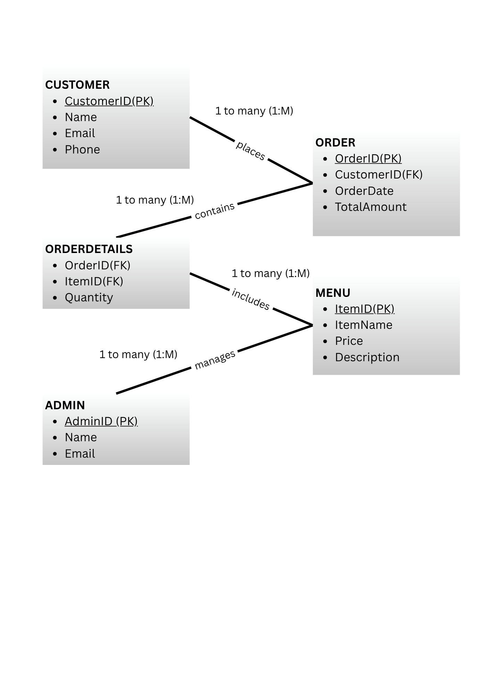

EXPECTED OUTCOMES:
- A fully functional and well-structured relational database system for an Online Food Order System.
- Efficient storage, organization, and retrieval of data with minimal redundancy.
- Improved data consistency, integrity, and reliability through proper database design.
- Faster and optimized query execution for retrieving required information.
- Strong practical understanding of core DBMS concepts such as ER modeling, normalization, and SQL operations.
- Hands-on experience in designing and implementing a real-world database application.

CONCLUSION:

The Online Food Order System effectively demonstrates the practical application of Database Management Systems in a real-world scenario. It provides an efficient and structured approach to managing customer, menu, and order data while ensuring accuracy, consistency, and reliability.

Through this project, we gained a deeper understanding of key DBMS concepts such as database design, normalization, and SQL query processing. It also helped in developing practical skills in designing relational databases and managing data efficiently. Overall, this system highlights how DBMS can be used to build scalable and well-organized solutions for real-life problems like food ordering systems.

REFERENCES:

- Korth, Database System Concepts
- W3Schools SQL Tutorial (www.w3schools.com/sql)
- Microsoft SQL Server Documentation

